GLOSS Group of Experts Meeting

February 2005

Charles Magori

Status Report of GLOSS Tide Gauges in Kenya

Introduction

There is growing concern about the rise in mean sea level around the globe. To address this concern, the Intergovernmental Oceanographic Commission (IOC) of UNESCO invited a group of experts to develop a Global Sea Level Observing System (GLOSS). The objective of GLOSS was to provide high quality standardized data from which valuable sea level products can be produced for international oceanographic such as World Ocean Circulation Experiment (WOCE) and regional research programmes as well as for practical application on a national level. Kenya is one of the countries participating in GLOSS and has already received support and assistance in terms of training of our specialists and provision of equipment through IOC.

In Kenya, the first gauge was installed in 1933 in Kilindini harbour, Mombasa by the former East Africa Railways and Harbours Corporation and was in operation until 1956. Another gauge (Munro gauge) was installed in the 1960's at the Kipevu pilot jetty at the present Kenya Ports Authority Headquaters and operated intermittently upto 1976. However, little data is available from this gauge. In 1975/6, a team from the Permanent Service for Mean Sea Level (PSMSL) collected one-year continuos data.

In the late 1980’s, the University of Hawaii in collaboration with the TOGA Sea Level Centre established a network of sea-level stations, which continue to provide useful information. Realising the importance of sea level data for navigation and harbour planning, beach protection and development and overall marine research, Kenya Marine & Fisheries Research Institute (KMFRI) requested for a tide gauge through IOC-UNESCO from the University of Hawaii (UH) in June, 1986 to start its tide gauge network. Following that request, the University of Hawaii donated a tide gauge, which was installed at Liwatoni jetty in Kilindini harbour, Mombasa. A second tide gauge was installed by UH in Lamu in 1996. KMFRI is responsible for maintaining both the Mombasa and Lamu tide gauge stations. Two KMFRI Technicians are attached to each station.

The TOGA Sea Level Centre (TSLC) in collaboration with the University of Hawaii agreed to assist in upgrading Kenya’s stations so as to ensure continuos availability of good quality data. Modern tide loggers, measuring sea level every 15 minutes interval were installed. The Lamu gauge was in addition equipped with a satellite data transfer device to enable real-time access to data. This ensures better control on the timeliness and reliability of data. Both Mombasa and Lamu are principal stations on the Global Sea Level Observing System (GLOSS). Both stations continue to operate well and data is available. Kenya is also coordinating the regional component of GLOSS.

Present Status of GLOSS Stations in Kenya

Mombasa Tide Gauge (Latitude: 04º 04´S Longitude: 039º 039’E)

A Leopold Stevens gauge was installed in Mombasa in 1986. This was later changed to a Fisher and Porter float gauge in 1991. The station continues to operate well and data is available. Some of the benchmarks were removed during construction work at the harbour where the gauge is located. The Mombasa gauge is float type installed on a stilling well. The station is equipped with modern data logger, measuring sea level every minute and storing on diskette at 15 minutes interval.

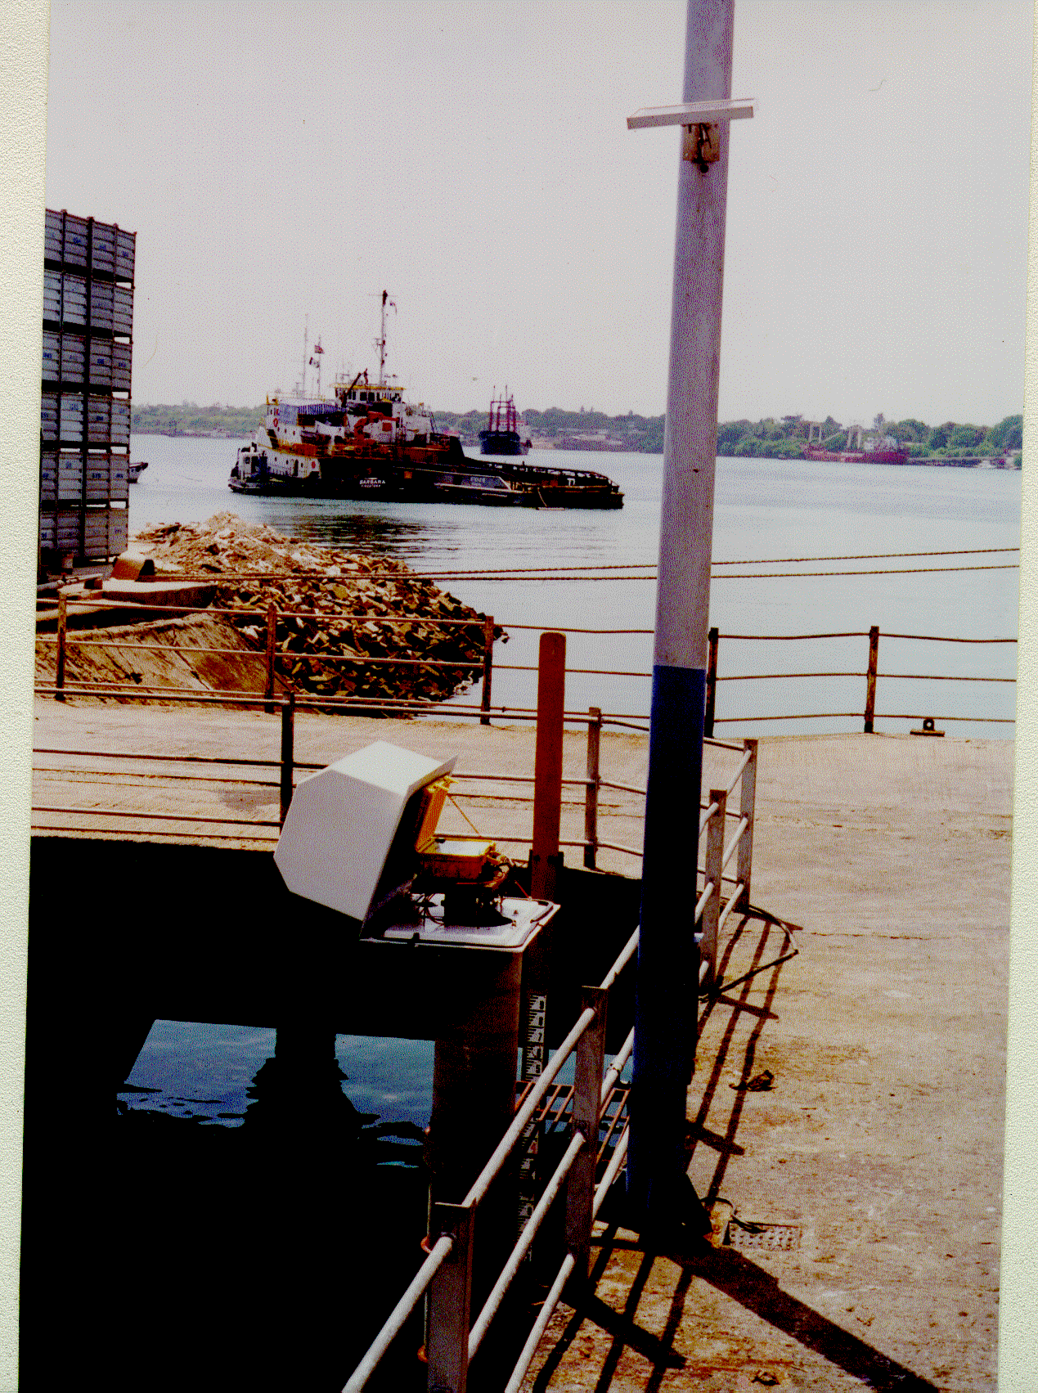

Photograph of Mombasa Tide gauge

Lamu Tide Gauge (Latitude: 02º 17´ S; Longitude: 040º 54’ E)

The Lamu gauge is a float type installed on a stilling well. It was installed in 1996 by the University of Hawaii Sea Level Centre (UHSLC). The station is equipped with modern data loggers, measuring sea level every minute and storing on diskette at 15 minutes interval. In addition, the Lamu tide gauge is equipped with a satellite data transfer device to enable real time access to data. Earlier, there was a Valeport BTH 700 gauge was installed at the end of 1988 but was not operational since 1992. This was due to a problem with electrical connection on the jetty where it was installed. During the time the gauge was out of operation, data was collected manually at half hour interval during day time (0900 to 1600 HRS).

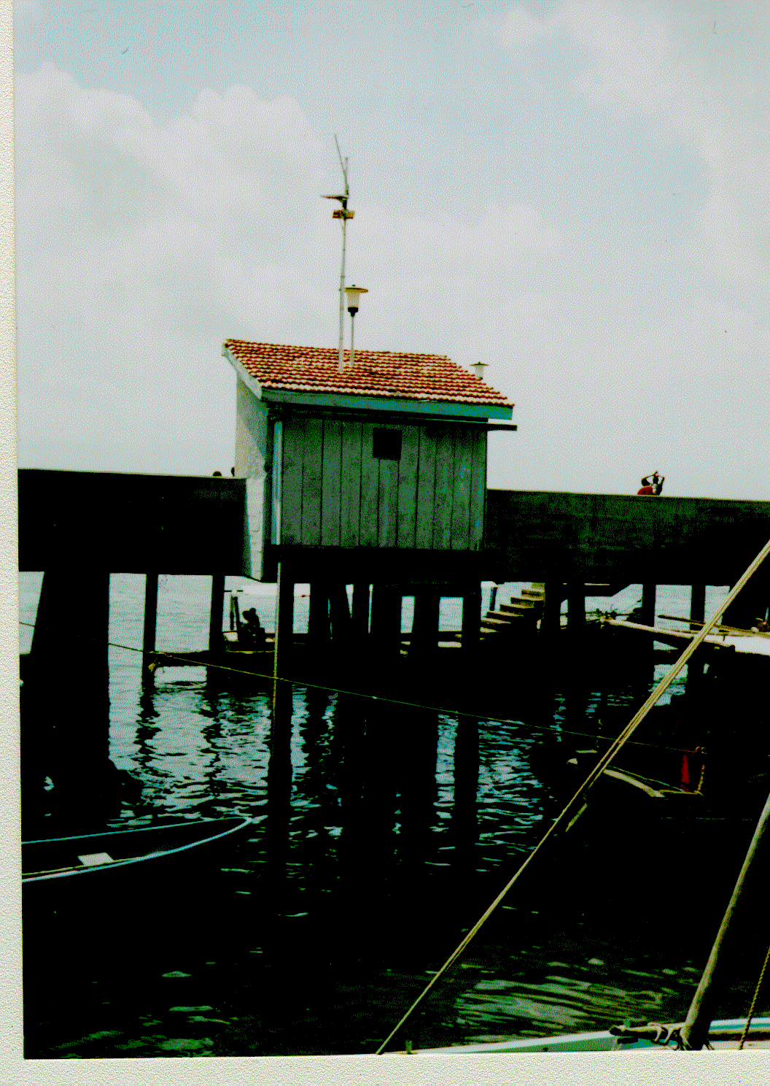

Lamu tide gauge house

Proposed Stations

There is a proposal to install three additional tide gauges. These will be at: Shimoni (4º 39´ S, 39º 23´E), Malindi (3º 15´S, 40º 08´E) and Kiunga (1º 45´S, 41º 29´E). We aim to have five stations to cover the Kenyan coast. The Malindi site has been proposed for installation of a new gauge within the framework of ODINAFRICA III project.

The objectives of having additional stations is to enable high spacial resolution of sea level observations, hence generate better needed time series of sea level data for scientific, management and for local use as well as international use. In addition, Kiunga gauge will be closest to the Equator and the only one within the Somali Current reversal zones and will thus cover an area of great interest to local scientists and the international scientific community as well.

The proposed gauges are part of the National sea level programme. The aim of the programme is to provide sea level data and products to all categories of users in Kenya. This information is particularly important at the moment due to the increasing concern about global warming and related sea level rise. It is also useful for other institutions including: Fisheries department, Kenya Ports Authority, Kenya Navy and Survey of Kenya among others.

Data From Mombasa And Lamu Stations

The sea level data (hourly, daily and monthly means) for the Kenyan stations are available at KMFRI in JASL format. Sea level data from both Mombasa and Lamu is send to University of Hawaii Sea Level Centre (UHSLC) Permanent Service to Mean Sea Level (PSMSL).

For Mombasa station, available data is from 1975/6 and 1986-2004.
The data available from Lamu station is in digital form and analogue charts. The digital data is from 1989, and 1996–2005 and the analogue chart is from 1990 to 1992. All the digital data from both stations are available in International data centres namely PSMSL and UHSLC.

The data can also be obtained from the following web sites.
- http://www.soest.hawaii.edu/UHSLC
- http://www.pol.ac.uk/psmsl/gloss.info.html

Capacity Available

There is still limited capacity for repair and maitenance of the two gauges. Lack of spare parts and tools has been a major hindrance to carrying out minor repairs jobs and levelling. We rely on services of technicians from UH Sea Level Centre for installation and maintenance of the two tide gauges. Regular maintenance of both gauges is supervised by KMFRI’s Principal Laboratory Technologist (Mr. Ben Ogega) and the National Sea Level contact (Dr. Charles Magori).

None of the Technicians on site has received training at PSMSL, UHLC, etc. However, a few of them have received in-service training and some additional hints during the visits to Kenya by field technicians from UHSLC. This has contributed considerably in improving the accuracy of the data.

Three Kenya scientists have received training sponsored by IOC. The training is on Sea Level Data Analysis and Interpretation. They are Mika Odido at PSMSL, UK in 1992, Charles Magori at Dehra Dun, India in 1995 and Clive Angwenyi in Cape Town, South Africa in 1998.

Recommendations

In order to have a national network that is fully operational, there is an urgent need to develop capacity for installation and maitenance of tide gauges and also for analysis and quality control of data. This will enable KMFRI to produce high quality sea level products for local scientists and international programmes and data centres.

GLOSS and ODINAFRICA III project should consider organising a regional training workshop for local scientists and technicians. The topics to be covered during the workshop should include:

- Review of sea level equipments: types, installation, levelling and maintenance.
- Processing and quality control of data.
- Analysis of data and products preparation.

The national network will be greatly strengtened through regular maintenance and levelling of benchmarks, maintenance of gauges, supply of spares and observer supervision. The national network of tide gauges will also contribute to enhancing the regional sea-level monitoring network. This is crucial considering that the region is an important component in the formation of the Indian Ocean Tsunami Early Warning System.

The Mombasa tide station should be equipped with facilities for satellite transmission of data. This will provide a real-time data network. ODINAFRICA III has been requested to consider upgrading both Mombasa and Lamu stations by equipping them with additional metocean sensors.

The national data and information task component of ODINAFRICA III, which started recently should archive copies of sea-level data from both stations and associated environmental data and also encourage exchange of sea level data and information in the country.

